Technical Project Team

Migrating Virtual Machines utilizing VMWare Replication Appliance
Standard Operating Procedure

PREPARED BY
Kelvin Aruin – Senior Technical Project Engineer

TABLE OF CONTENTS
Migrating a VM to New VMWare Environment 3
Prerequisites 3
Procedure 3
Results 4

Migrating a VM to New VMWare Environment

Prerequisites
Verify that the virtual machine has been fully replicated and the status is ‘OK’
Verify that the virtual machine at the source site is powered off. If the virtual machine is powered on, an error message reminds you to power it off.

Procedure
- Log in to the target site by using the vSphere Client.
- On the home page, click Site Recovery and click Open Site Recovery.
- On the Site Recovery home page, select a site pair and click View Details.
- Click the Replications tab and select a replication from Incoming.
- Make sure the status of the virtual machine is ‘OK’. Any other status will not allow the process to run.
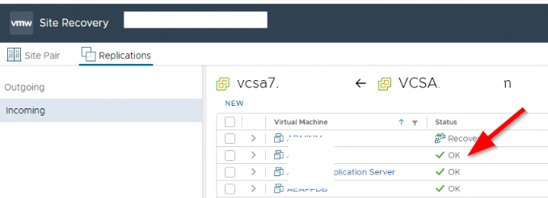
- Click the Recover icon.
- Logon to the source Vcenter or ESXI host and power down the machine you are migrating as you will not be able to continue otherwise.

- Select whether to recover the virtual machine with all the latest data, or to recover the virtual machine with the most recent data available on the target site.
Option | Description
Synchronize recent changes | Performs a full synchronization of the virtual machine from the source site to the target site before recovering the virtual machine. Selecting this option avoids data loss, but it is only available if the data of the source virtual machine is accessible. You can only select this option if the virtual machine is powered off.
Use latest available data | Recovers the virtual machine by using the data from the most recent replication on the target site, without performing synchronization. Selecting this option results in the loss of any data that has changed since the most recent replication. Select this option if the source virtual machine is inaccessible or if its disks are corrupted.
- (Optional) Select the Power on the virtual machine after recovery check box.
- Click Next.
- Select the recovery folder and click Next.
- Select the target computer resource and click Next.
- (Optional) If the virtual machine contains hard disks for which you have not activated replication, select a target destination to attach an existing disk or detach the disk, and click Next.
This page only appears if the virtual machine contains hard disks for which you have not activated replication.
  - To select a target destination, click Browse and navigate to a folder on a datastore in which disk file is placed.
  - To detach the disk and exclude disk files from the recovery, click Detach.
- Click Finish.

Results
vSphere Replication validates the provided input and recovers the virtual machine. If successful, the virtual machine status changes to Recovered. The virtual machine appears in the inventory of the target site.
If you activated multiple point-in-time instances when you configured replication for the virtual machine, vSphere Replication presents the retained instances as standard snapshots after a successful recovery. You can select one of these snapshots to revert the virtual machine. vSphere Replication does not preserve the memory state when you revert to a snapshot.
If the recovery fails, the replication of the virtual machines reverts to the replication state before the attempted recovery. For more information about the failed recovery attempt, check the last recovery error message in the replication details pane or check vCenter Server tasks.
The recovery might also fail if you use the same name for the virtual machine in a scenario where you use vSphere Replication to replicate a virtual machine in a single vCenter Server and the vCenter Server instance has only one host in its inventory. See Error Recovering Virtual Machine in a Single vCenter Server Instance for more information.
After a successful recovery, vSphere Replication deactivates the virtual machine for replication if the source site is still available. When the virtual machine is powered on again, it does not send replication data to the recovery site. To unconfigure the replication, click the Remove icon.
When the source virtual machine is no longer in the vCenter Server inventory, the replication is removed from the Outgoing tab, but it can still be found in the Incoming tab on the target site.
If a replicated virtual machine is attached to a distributed virtual switch and you attempt to perform a recovery in an automated DRS cluster, the recovery operation succeeds but the resulting virtual machine cannot be powered on. To attach it to the correct network, edit the recovered virtual machine settings.
vSphere Replication disconnects virtual machine network adapters to prevent damage in the production network. After recovery, you must connect the virtual network adapters to the correct network. A target host or cluster might lose access to the DVS the virtual machine was configured with at the source site. In this case, manually connect the virtual machine to a network or other DVS to successfully power on the virtual machine.

